LOG:

After trying many methods which produced either scores or zones. Finally used **sliding window Technique**, -Calculated the score for each window and checks if the window is non-overlapping with previously selected zones.

**Zone Selection and Validation**,The is_non_overlapping function checks if a new zone overlaps with any previously selected zones.

Used logging python library module for debugging where I could see the zones and best zones but there was no output only judge score was generated. Hence discared.

Claude3.5 sonnet was better for this program

Issues::

1.When I run python judge.py min.dat ans2.py it generates a score (say 182354) but I cannot see the zones.

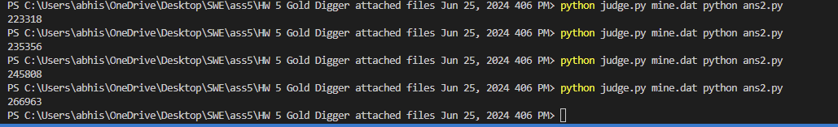

we got High scores but upon debugging realized it is traking best score from 1 zone and multiplying 5 times.

*Increased attempts for better score. Longer compilation time.

Some of the zones our code produced.

6780 8779 29115 31114 46241 48240 72903 74902 82853 84852

Total Score: 86694.19635913082

Abhishek Saketh priya